**Art Studio Kit**

7th & 8th Grade – Ms. Pierce

Fort Settlement Middle School - FBISD

For your convenience, we have created pre-packaged studio kits for $47.00. Pre-packaged studio kits may be purchased

at the FBISD – Middle Schools - FSMS Fine Arts web store (click on the shopping cart icon at the bottom of the web page).

Kits can be picked up in the art room with your online printed receipt.

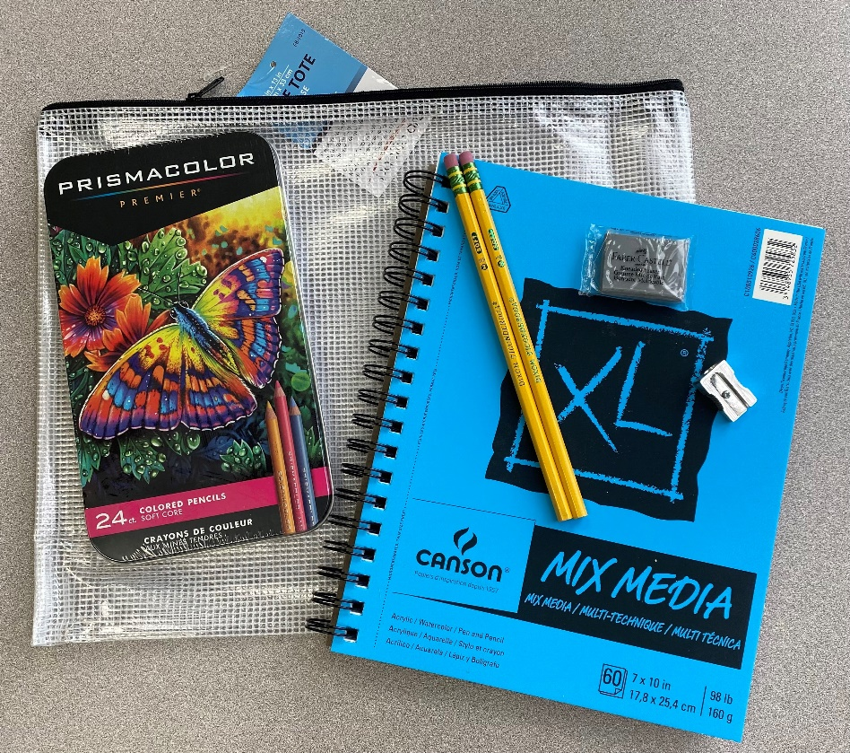

Canson Side Spiral 7x10” XL Mixed Media Sketchbook 60ct

#2 Ticonderoga Pencils

Faber Castell Kneaded Eraser

Single Metal Pencil Sharpener

Prismacolor Primier 24 ct

10x13” Mesh Zippered Storage Bag